Exercise 1: Using visuals to predict content. 練習1: 觀看來預測內容

1.

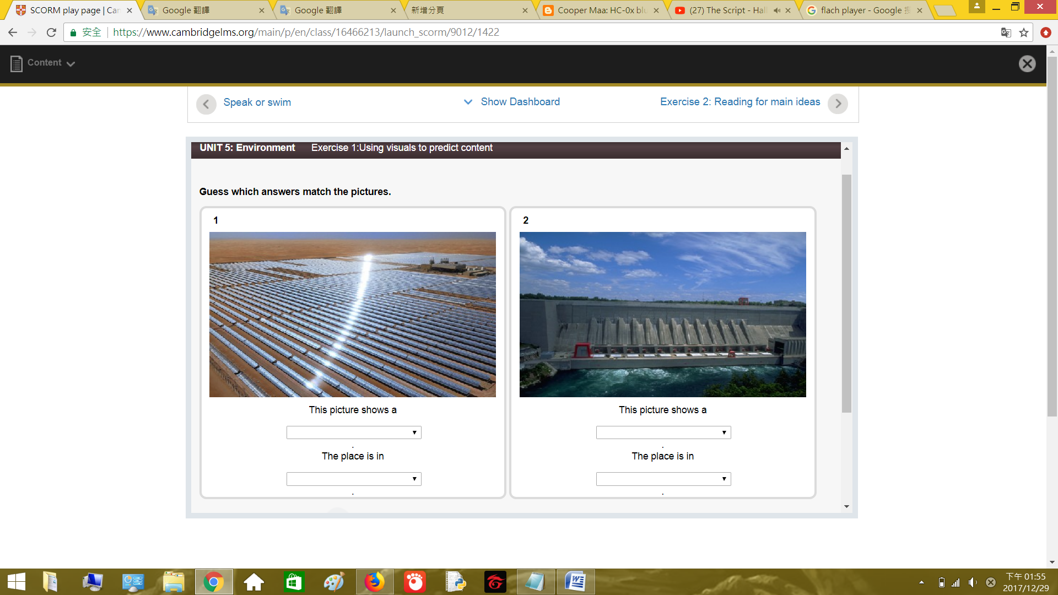

This picture shows a solar power plant.

太陽能發電廠的圖片

The place is in Abu Dhabi

在阿布扎比

2.

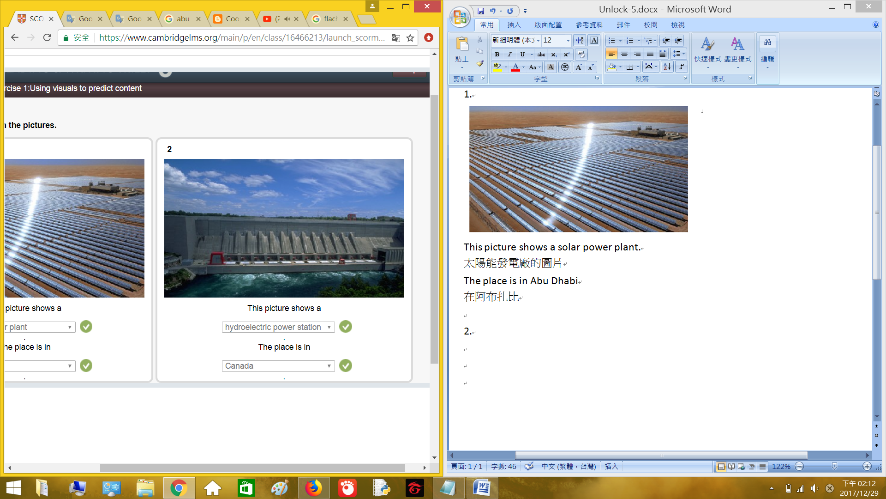

This picture shows a hydroelectric power station.

水力發電廠的圖片

The place is in Canada.

在加拿大

Exercise 2: Reading for main ideas. 練習2: 閱讀重點

Read the article. Put the ideas in the order they are mentioned.

閱讀文章.放置提到的點子順序.

The future has to be green 未來要是綠色

There is no doubt that our planet is getting warmer and it is generally agreed that is caused by the high levels of greenhouse gasses, such as carbon dioxide (CO2), in the atmosphere. There gases are created when we burn fossil fuels for energy. However, there are renewable source of energy which can be used as greener alternative to fossil fuels. This essay will look at two of the major alternative sources of energy: solar and hydroelectric. It will conclude that more of our power need should come from these energy sources if we are to reduce the speed of global warming.

不要懷疑我們的星球正在暖化,因為有高壓的溫室氣體(二氧化碳),在大氣層.當我們燃燒化石燃料取得能量時,就會產生這氣體.然而再生能源能更環保的取代化石燃料.文章有兩個主要的替代能源:太陽能和水力.結論,多使用這些能源能減少全球暖化的速度.

A lot of countries in the Gulf do not only have plenty of oil but also plenty of sun. This sunshine, together with a lot of unused desert land, means that they are the ideal locations to build solar power plants. Indeed, one of the largest solar power plants in the world is the Shams 1 plant in Abu Dhabi. The plant consists of over 258,000 mirrors, covering an area larger than 285 football pitches. The solar plant works by using the mirror to focus heat onto pipes, which are filled with a special type of oil. The heated oil is then used to produce steam, which drives the turbines that change mechanical energy into electrical energy, just like in a traditional electricity generating plant. The energy from this plant is enough to power over 20,000 home. To produce this much power from fossil fuels, over 175,000 tons of CO2 would be pumped into the air every year.

許多國家有海灣,海灣不只有充足的油也有充足的太陽.許多未使用的沙漠區域有陽光,在這些地方建立太陽能發電廠.確實,世界最大的太陽能發電廠之一在Abu Dhabi的Shams工廠.這工廠由超過258,000個鏡子組成,覆蓋這區域285個足球場的大小.太陽能發電廠的運作由鏡子將熱聚焦到管子上,管子填充特殊的油.油加熱後產生蒸氣,蒸氣啟動渦輪機將機械能轉成電能,就像傳統的發電機.工廠產生的能量足夠提供20,000家庭使用.化石燃料產生許多電能,每年超過175,000頓的二氧化碳排到空中.

A country like Canada does not have as much sun as countries in the Middle East, but it does have plenty of water. Nearly 60% of Canada’s electricity comes from hydroelectric power, making it one of few countries which generates most of its power from renewable sources. One of the most important hydroelectric power stations is the one in the Niagara River, near to the world-famous Niagara Falls. Between 50% and 70% of the water from the river goes through four huge tunnels before the waterfalls. This water then passes through special turbines which provide energy to nearby areas of Canada and United States. Once the water has passes through the turbines, it is then returned to the river after waterfalls.

加拿大這國家沒有像中東國家有許多陽光,但有豐富的水.加拿大幾乎60%的電力來自水力發電,是使用再生能源的少數國家之一.Niagara河川是重要的水力發電廠之一,靠近世界知名的Niagara瀑布.這瀑布50%到70%的水從河川通過四大隧道而來.水通過特殊的渦輪提供能量給加拿大和美國附近的區域.一旦水經過渦輪,水會回到河川之後流到瀑布.

The Middle East has nearly half the world’s solar energy potential and many countries other than Canada have significant amounts of water that can be used to generate electricity. The important question – will all these natural resources start to be used in place of burning the fossil fuels which are killing our planet? If our environment is to survive, then immediate action must be taken to ensure more power comes from renewable sources such as the sum and water.

中東將近有世界一半的太陽能潛力,許多加拿大以外的國家有相當數量的水能生產電力.重要的問題-將所有的自然資源使用在燃燒化石燃料,會殺死我們的星球?如果我們的環境要生存,必須立刻採取行動,確保更多電力是使用再生能源的太陽和水.

1. Why our planet is getting warmer.

為何我們的星球在暖化.

1. How greenhouse gases are created.

溫室氣體是怎麼產生.

1. Countries that have a lot of sunshine and desert land.

這國家有不少的陽光和沙漠.

1. A large solar power plant.

一個大型的太陽能發電廠.

1. A country that gets most of its power from renewable energy.

這國家大部分的電力是使用再生能源.

1. How water creates power.

水怎麼產生電力.

Exercise 3: Scanning to find information 練習3: 尋找來發現信息

Scan the article quickly and complete the sentences.

尋找文章快速並完成句子

1. Over 50% of the water in the Niagara River goes through the hydroelectric power generator.

在Niagara河川超過50%的水通過水力發電機.

1. Over 175,000 tons of carbon dioxide is saved every year by the Shams 1 solar power plant.

Shams 1太陽能發電廠,每年節省超過175,000噸的二氧化碳.

1. The Shams 1 power plant is bigger than 285 football pitches.

Shams 1電力場大於285的足球場.

1. Canada produces almost 60% of its energy from renewable sources.

加拿大生產將近60%的能源是使用再生能源.

1. The Shams 1 power plant can provide enough electricity for 20,000 home.

Shams 1電力發電廠能提供足夠的電力給20,00家庭使用.

1. Over 258,000 mirrors are used in the Shame 1 power plant.

超過258,000個鏡子使用在Shame 1電力發電廠.

Exercise 4: Making inferences 練習4: 進行推理

Complete the table by writing one word in each space. Use the words in the box.

完成表格,在每個空間寫入單字.使用方塊內的字.

|  |  |
| --- | --- |
| Cause 原因 | Effect 影響 |
| People burn fossil fuels around the world.  人們在世界各地燃燒化石燃料. | The amount of greenhouse gas in the atmosphere increases.  溫室氣體在大氣層增加. |
| There is a lot of greenhouse gas in the atmosphere.  不少的溫室氣體在大氣層. | The planet warms up.  星球溫度上升. |
| Sunshine on mirror at the solar plant.  陽光照射太陽能電廠的鏡子. | The sun’s heat is focused onto the pipes.  太陽的熱集中在管子上. |
| The sun heats up the special oil in the pipes.  太陽加熱管子內的特殊油. | The hot oil heats water to make steam.  熱油加熱水產生蒸氣. |
| The steam drives the turbines.  蒸氣啟動渦輪. | The mechanical energy from the turbines makes electrical energy.  機械能被窩輪轉為電能. |
| Renewable sources produce energy instead of fossil fuels.  再生能源取代化石燃料產生能量. | Less greenhouse gas goes into the atmosphere.  減少大氣層的溫室氣體. |

Exercise 5: Vocabulary A 練習5: 詞彙

Choose the correct words to complete the sentences.

選擇正確的字來完成句子.

1. If the sea rises by even a small amount, many low – lying islands will be submerged.

如果海平面少量的上升,許多盆地島嶼將被淹沒.

1. A glacier is a large mass of ice which moves very slowly.

冰川是巨大的冰塊行動非常慢.

1. About a quarter of the land on earth is used for agriculture.

地球上四分之一的土地使用於農業.

1. One cause of deforestation is subsistence farming.

自製化農場是砍伐森林的原因之一.

1. Biodiversity is also affected by deforestation.

砍伐森林會影響生物多樣性.

1. The effects of deforestation are damaging the natural habitat of many animals.

砍伐森林會影響自然生態,傷害許多動物.

Exercise 6: Vocabulary B 練習6: 詞彙B

Match the causes to the effects.

配對原因的影響.

|  |  |
| --- | --- |
| Cause 原因 | Effect 影響 |
| greenhouse gases | global warming |
| melting glaciers 融化的冰川 | rising sea levels |
| droughts 乾旱 | aridity |
| deforestation 砍伐樹林 | loss of habitat |
| fossil fuels 化石燃料 | carbon dioxide |
| logging 木材 | deforestation |

Exercise 7: Cause and effect 練習7: 原因和影響

Choose true or false for each statement.

對敘述選擇真的或假的

|  |  |  |
| --- | --- | --- |
|  | True | False |
| Melting glaciers are caused by higher temperatures | ☑ |  |
| Higher temperatures lead to increased greenhouse gases. |  | ☑ |
| Burning fossil fuels is the result of more greenhouse gases. |  | ☑ |
| Deforestation is caused by commercial agriculture and subsistence farming. | ☑ |  |
| Deforestation results in soil erosion | ☑ |  |
| Using renewable energy sources is the result of improvement of the environment. |  | ☑ |

Exercise 8: Using because and because of 練習8: 使用because 和 because of

Choose the correct words to complete the sentences.

選擇正確的字來完成這句子.

because of 屬於: 介係詞

相關說明: https://tw.blog.voicetube.com/archives/39456

1. The amount of greenhouse gas is increasing because of the amount of fossil fuels we are burning.

溫室氣體總量在增加,因為燃燒化石燃料.

1. We need to find alternative sources of energy because burning fossil fuels is damaging the environment.

我們需要尋找替代能源,因為燃燒化石燃料是傷害環境.

1. Abu Dhabi is a good place to build a solar power plant because there is plenty of sun and unused space in the desert.

Abu Dhabi是個建立太陽能發電廠的好地方,因為這地方有豐富的陽光和未被使用的沙漠地區.

1. Canada is able to produce a lot of hydroelectricity because of the Niagara Falls.

加拿大能生產不少的水力發電,因為Niagara瀑布.

1. Many glaciers in the world are beginning to melt because of global warming.

世界上許多冰川開始融化,因為全球暖化.

1. Many glaciers in the world are beginning to melt because the planet is getting warmer.

世界上許多冰川開始融化,因為行星變溫暖.

Exercise 9: Topic sentences 練習9: 主題句子

Match the sentence halves.

匹配半個句子.

1. Our increasing need for energy is causing damage to the environment.

我們需要增加能源,這造成環境傷害.

1. The environment can be improved by using renewable energy sources such as solar and hydroelectric power.

使用太陽能和水力發電,這些再生能源能改善環境.

1. Animals are suffering because of the destruction of their habitat, which is caused by global warming and deforestation.

全球暖化和砍伐森林使動物痛苦,因為棲息地被破壞.

1. Countries in Northern Europe are not very good places to build solar power plants because they do not have much sunshine.

北歐這國家不是建立太陽能發電的好地方,因為這裡沒有很多太陽.

1. Hydroelectric power station can be found in countries like Canada, where there is a lot of water.

像加拿大的國家能發現水力發電廠,這裡有不少水.

1. There are several ways in which we can help improve our environment.

有幾個方法能幫助改善我們的環境.

Exercise 10: Topic sentences and paragraph structure 練習10: 主題句和段落結構

Put the sentences in order to make a paragraph about wind power.

放置句子來完成關於風力的段落.

As well as solar and hydroelectric power, wind power is now being used to generate electricity.

現在使用太陽能和水力跟風力來發電.

In America, China and many countries in Europe, wind farms are being built.

在美國和中國跟歐洲許多國家建立風力發電廠.

Each of these wind farms is made up of anything between three and several hundred wind turbines.

每個風力發電廠都有三到數百個的風力發電機.

There are advantages and disadvantages to onshore wind farms.

陸地上的風力發電廠的優點和缺點.

說明: onshore陸地上 offshore 海上

Onshore wind farms are closer to where the energy is needed, but because of the way wind travels over land they are not very productive.

陸地上的風力發電廠靠近需要能源的地區,但風力會被陸地而削弱.

Along with the sun and water, the wind is now being used as a clean way to generate energy and in the future we will see more wind turbines in our landscape.

太陽和水跟風是現在乾淨生產能源的方法,在未來我們將看到更多風力發電機.

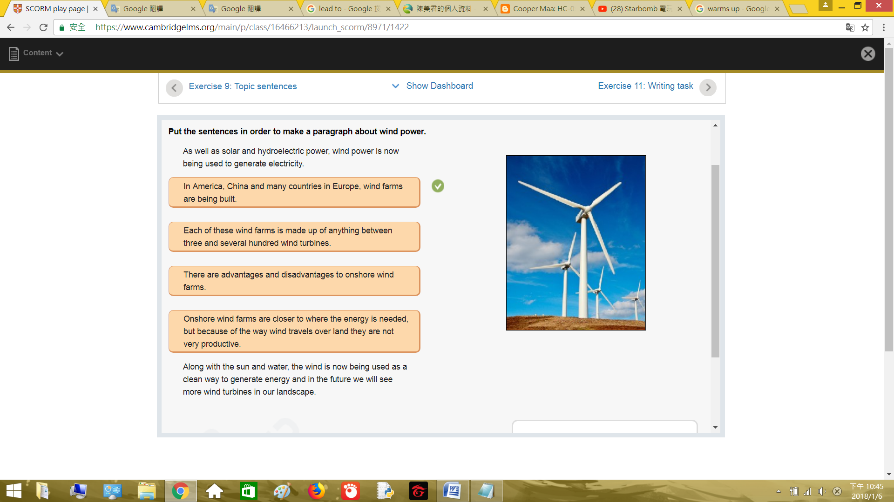

Exercise 11: Writing task 練習11: 作文

Unit 5: Additional writing task 單元5: 增強寫作技巧

Think of an environmental problem facing your country. What are the reasons for this problem? What will the consequences be if no solution is found?

思考自己國家的環境為題.有什麼解決辦法?如果沒有解決會有什麼後果?

Air pollution 空氣汙染

Sometimes the tiger tail air is full of stink.When night can obviously see the fog under the street lamp, on the outside of the locomotive, a few days after the surface will have a layer of ash. People dare to go out exercise.

有時虎尾的空氣充滿了臭味.晚上時能在路燈下明顯的看見霧,放在外面的機車,幾天後表面會有一層灰.讓人不敢出外運動.

These toxic gases are discharged from the factory, in order to save money so toxic gas emissions at will, causing the city full of gas.

這些有毒氣體都是工廠排出來的,為了省錢所以將有毒氣體隨意排放,造成城市充滿了毒氣.

The most effective solution, less out to reduce exposure to toxic gases, go out to wear a mask, buy air cleaner, the room of toxic gases cleared of If you do not have the above points, your lungs will lose their function, Will die early, and even if you do these things, the natural environment will be polluted sooner or later, will not be able to live here.

最有效的解決辦法,少出門減少接觸到有毒氣體,出門時要戴上口罩,買空氣清淨機,把房間的有毒氣體清除.如果沒辦法做到以上幾點,你的肺將會失去功能,會早死.而且就算你有做到這幾點,自然環境遲早也會被汙染,這裡將不能再居住.

Game: 遊戲:





